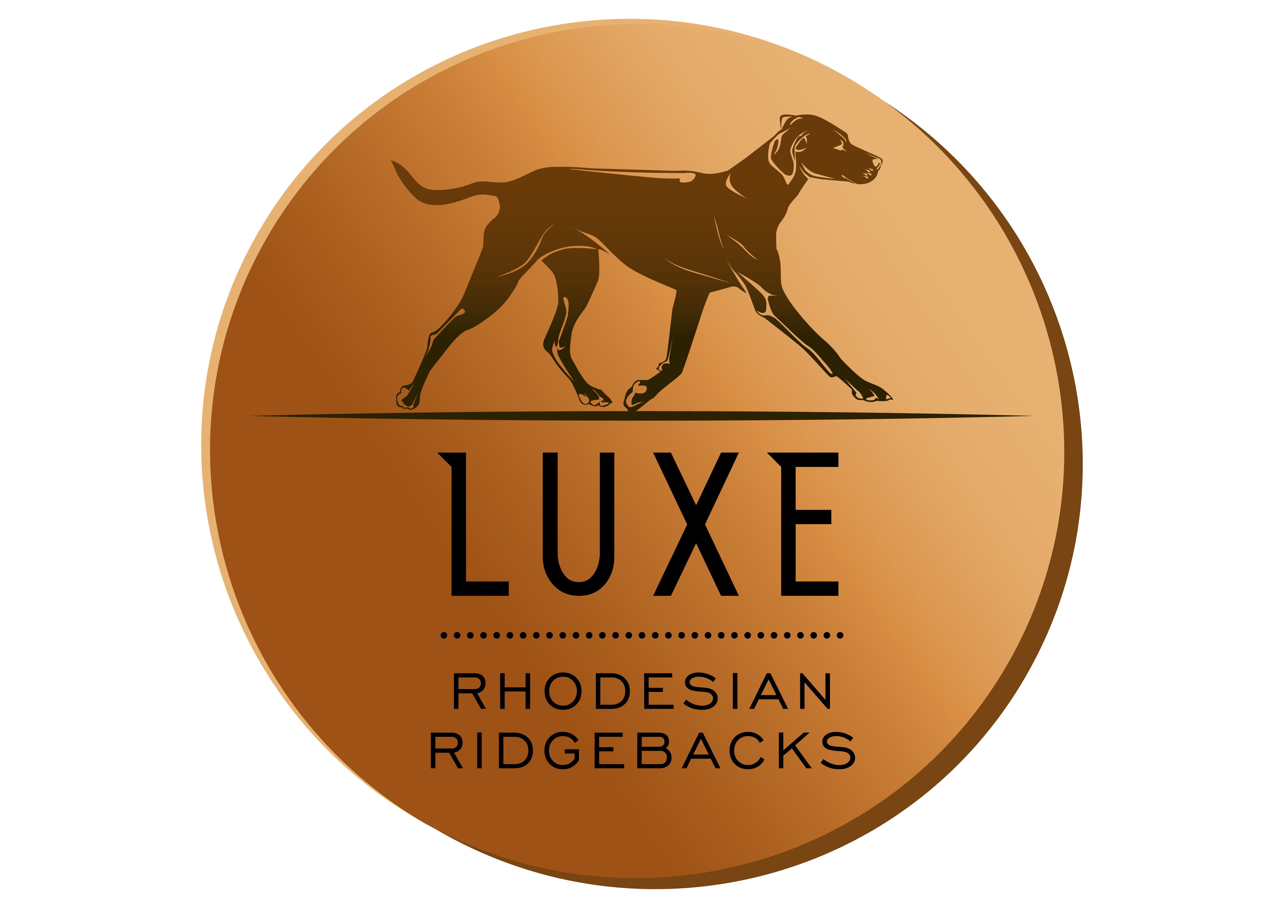

luxerhodesians@gmail.com
250-816-3734 (Kate)
250-268-5000 (Derrick)

Today’s Date:

Full Name:
Spouse’s Name:
Permanent Home Address:
City:
Province/State:
Postal Code/Zip:
Home Phone:
Cell Phone:
Email Address:

Thank you for your interest in the companionship of a Luxe Rhodesian Ridgeback. Ridgebacks are very appealing due to their striking physical appearance, however, like all dogs, they have traits that may not be appropriate for every owner. They are not for everyone and come with a large responsibility due to their size, strength and natural protective nature.

Our preference is to place puppies in the homes of people we have met in person and have met our dogs and had the opportunity to be educated by us and spend time with the dogs learning about some of their intricacies. We often require a home check, ridgeback puppies find endless ways to get themselves into trouble and we can help pinpoint some of the hazards.

The completion of this questionnaire does not guarantee your approval for a puppy/dog, this is merely a tool and a beginning of a dialogue between Luxe Kennels and you.

Please Note: WE DO NOT SELL PUPPIES FOR CHRISTMAS PRESENTS OR ANY OTHER TYPE OF GIFT. The person(s) filling out this questionnaire will receive the puppy and be responsible for the puppy.

If you fill the application out electronically, please use red or blue for your responses.

Where did you hear about Luxe Rhodesian Ridgebacks?

Do you own or rent your home?
Do you have a yard?
Is your yard fenced?
If fenced, how high is the fence and of what material is it constructed?
Are you married, single, in a relationship?
Children? If so, what ages?
Do you work full time? What are your typical hours?
Is there anyone home during the day?
Does anyone have allergies or sensitivities? If so, what are they?

Why do you think you, your family and home would be a good match for a Rhodesian Ridgeback?

What do you think this dog will be like? Behavioral Traits and Temperament?

What is your experience with previous pets and current pets? Tell us a bit about them.

What are those pets like and how do they interact with each other in the home and other animals?

Have you ever needed to surrender a dog or cat to a shelter or rescue? Sold or given an animal away? If so, what was the circumstance?

Do you kennel train? Please give a reason why or why not.

Where will the dog sleep?

If you go on vacation, will the dog go with you? If not, who will take care of the dog while you are gone?

What are your plans for the puppy/dog’s care during the day?
Have you ever taken obedience classes and socialization classes with a dog? Are you willing to?

Are you able to devote the necessary time to train and socialize a puppy in order for them to be a well rounded, balanced dog and good canine citizen? What kind of time and resource do you think that entails?

Do you have the necessary time to properly supervise a puppy for many months to avoid damage to landscaping, furniture and clothing? And avoid harm to the puppy/dog from ingestion of foreign items?

What do you plan to feed your new puppy? Kibble or raw diet, and why?

Why are you interested in owning a Rhodesian Ridgeback and why your home would be a great home for a Luxe puppy.

Please Circle Preferences: (this does not guarantee your choice but we do our best to accommodate your preference)

Male / Female / Either
Small / Medium / Large / Doesn’t Matter
Clean Face / Black Mask / Livernose / Doesn’t Matter
Ridged / Ridgeless / Either

Rate from 1-5 (1= low importance 5=highest importance)

- Friend/Family companionship
- Protection / Guardian
- Trainability
- Playing Games (balls/ frisbees)
  - Playing with other dogs not in your home
  - Hunting
  - Showing
  - Breeding
  - Competitive Agility
  - Other:______________________________

List two references with contact info, that are familiar with your family and lifestyle. (Friends, Veterinarians, co-workers etc.)

1.
2.

Anything you would like to add to this applications or tell us?

Thank you for filling out the questionnaire, this helps us immensely in getting to know you better and helps determine what type of puppy would best suit you. We choose our homes for the puppies with many variables in mind to ensure success. This process is a necessary step in making the best possible match for you for the next 10-14 years. We want those years to be rewarding and full of happiness for both you and your dog.

Once we review your application, and speak to you, we will let you know if you have been accepted for the puppy list. We do take a $500 deposit to ensure you get a puppy. After which you will receive regular updates on the pregnancy and the puppies as they grow. You will be welcome to come visit the dam and puppies.

If you have any questions, please feel free to contact us via phone or email or to arrange for a visit with our dogs.

Please email back the completed questionnaire to luxerhodesians@gmail.com.

Kate & Derrick Church

